Project Structure

|  |  |
| --- | --- |
| Team ID | PNT2022TMID51528 |
| Project Name | Detection of parkinson’s disease prediction using Machine Learining |

Existing System:

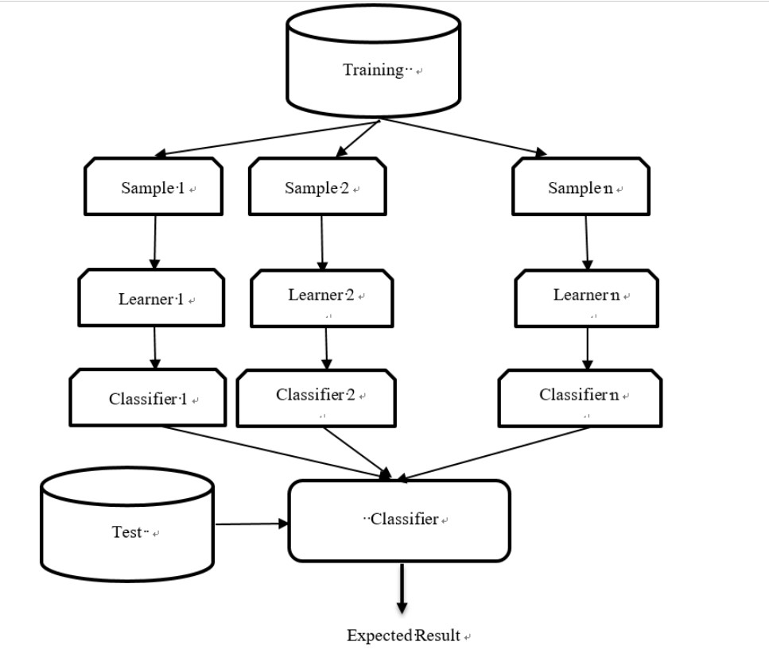

Proposed System:

